**[03-SelectionStructuresinPython](https://www.rajalakshmicolleges.net/moodle/course/view.php?id=84&section-3)**

**Ex. No. : 3.1 Date: 27/3/24**

**Register No.: 231801073 Name: Joseph Obearai J**

## [AdmissionEligibility](https://www.rajalakshmicolleges.net/moodle/mod/quiz/view.php?id=5706)

Writeaprogramtofindtheeligibilityofadmissionforaprofessionalcoursebased on the following criteria:

Marks in Maths>= 65 Marks in Physics >= 55 MarksinChemistry>=50 Or

Totalinallthreesubjects>=180 Sample Test Cases

TestCase1 Input

70

60

80

Output

Thecandidateiseligible Test Case 2

Input 50

80

80

Output

Thecandidateiseligible Test Case 3

Input 50

60

40

Output

Thecandidateisnot eligible

**For example:**

|  |  |
| --- | --- |
| **Input** | **Result** |
| 50  80  80 | Thecandidateiseligible |

# Program:

a=int(input()) b=int(input()) c=int(input())

if(a>=65 and b>=55 and c>=50): print("Thecandidateiseligible")

elif(a+b+c>=180):

print("Thecandidateiseligible") else:

print("Thecandidateisnoteligible")

# Output:

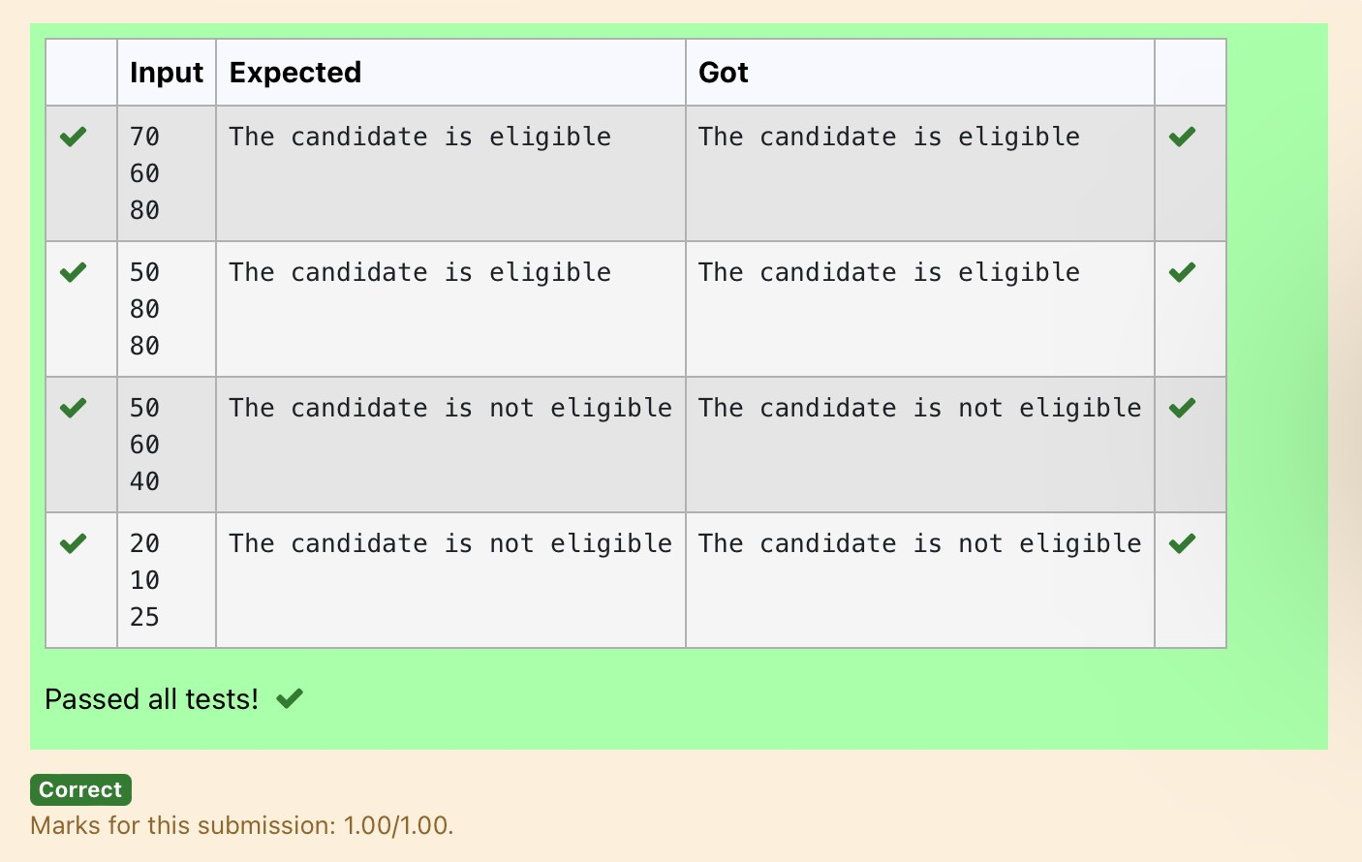

**Ex. No. : 3.2 Date: 27/3/24**

**Register No.: 231801073 Name: Joseph Obearai J**

## [ClassifyingTriangles](https://www.rajalakshmicolleges.net/moodle/mod/quiz/view.php?id=5707)

A triangle can be classified based on the lengths of its sides as equilateral, isosceles orscalene. All three sides of an equilateral triangle have the same length. An isoscelestriangle has two sides that are the same length, and a third side that is a different length.If allof the sideshave different lengthsthenthe triangleisscalene.

Writeaprogramthatreadsthe lengths of thethree sidesof a trianglefrom the user. Then display a message that states the triangle’s type.

SampleInput1

60

60

60

SampleOutput1

That'saequilateraltriangle

**For example:**

|  |  |
| --- | --- |
| **Input** | **Result** |
| 40  40  80 | That'saisoscelestriangle |

# Program:

a=int(input()) b=int(input()) c=int(input()) if(a==bandb==c):

print("That'saequilateraltriangle") elif(a!=b and b==c or a==b and b!=c):

print("That'saisoscelestriangle") elif(a!=b and b!=c):

print("That'sascalenetriangle")

# Output:

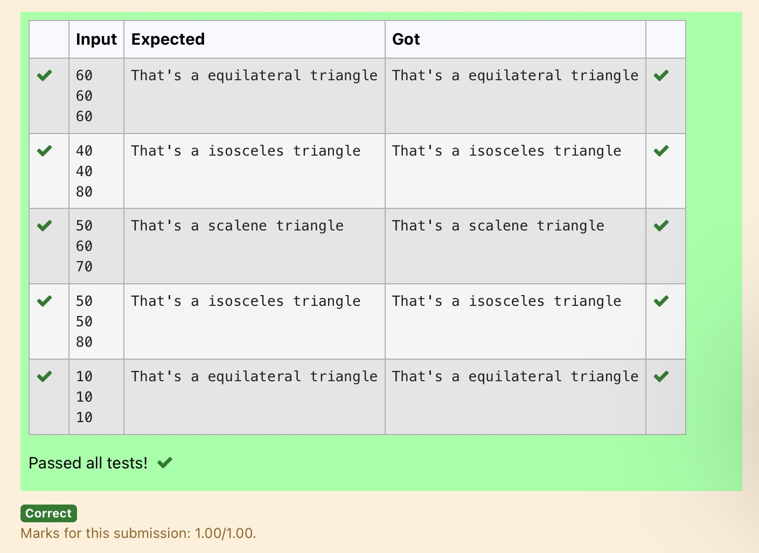

**Ex. No. : 3.3 Date: 27/3/24**

**Register No.: 231801073 Name: Joseph Obearai J**

## [ElectricityBill](https://www.rajalakshmicolleges.net/moodle/mod/quiz/view.php?id=5708)

WriteaprogramtocalculateandprinttheElectricitybillwherethe unit consumed by the user is given from test case. It prints the total amount the customer has to pay. The charge are as follows:

Unit Charge/ Unit

Upto199 @1.20

200andabovebutlessthan400@1.50 400andabovebutlessthan600@1.80 600 and above @2.00

IfbillexceedsRs.400thenasurchargeof15%willbechargedandtheminimumbill should be of Rs.100/-

SampleTestCases Test Case 1

Input 50

Output 100.00

TestCase2 Input

300

Output 517.50

**For example:**

|  |  |
| --- | --- |
| **Input** | **Result** |
| 500 | 1035.00 |

# Program:

a=float(input()) b=0

if(a<=199):

b=a*1.2 elif(200<=a<400):

b=a*1.5 elif(400<=a<600):

b=a*1.8 elif(a>600):

b=a*2.0

if (int(b)<100): print("{:.2f}".format(100))

else:

if(b>400.00):

print("{:.2f}".format((b+(b*0.15)))) else:

print("{:.2f}".format(b))

# Output:

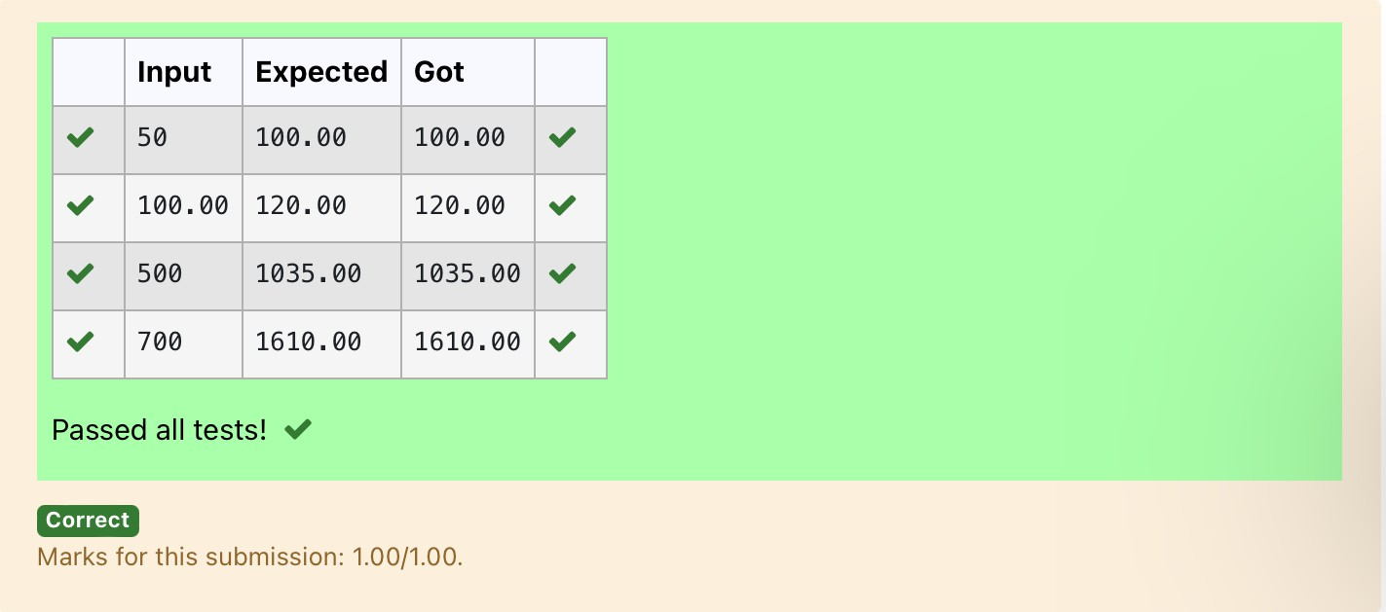

**Ex. No. : 3.4 Date: 10/4/24**

**Register No.: 231801073 Name: Joseph Obearai J**

## [IN/OUT](https://www.rajalakshmicolleges.net/moodle/mod/quiz/view.php?id=5709)

Ms. Sita, the faculty handling programming lab for you is very strict. Your seniors have told you that she will not allow you to enter the week's lab if you have not completed atleast half the number of problems given last week. Many of you didn't understand this statement and so they requested the good programmers from your batch to write a program to find whether a student will be allowed into a week's lab given the numberof problemsgiven last weekand the numberofproblemssolved by the student in that week.

InputFormat:

Inputconsistsof2integers.

Thefirstintegercorrespondstothenumberofproblemsgivenandthesecond integer corresponds to the number of problems solved.

OutputFormat:

Outputconsistsofthestring“IN”or“OUT”. Sample Input and Output:

Input 8

3

Output OUT

**For example:**

|  |  |
| --- | --- |
| **Input** | **Result** |
| 8  3 | OUT |

# Program:

a=int(input()) b=int(input()) c=(a/2)if(c>b):

print("OUT") else:

print("IN")

# Output:

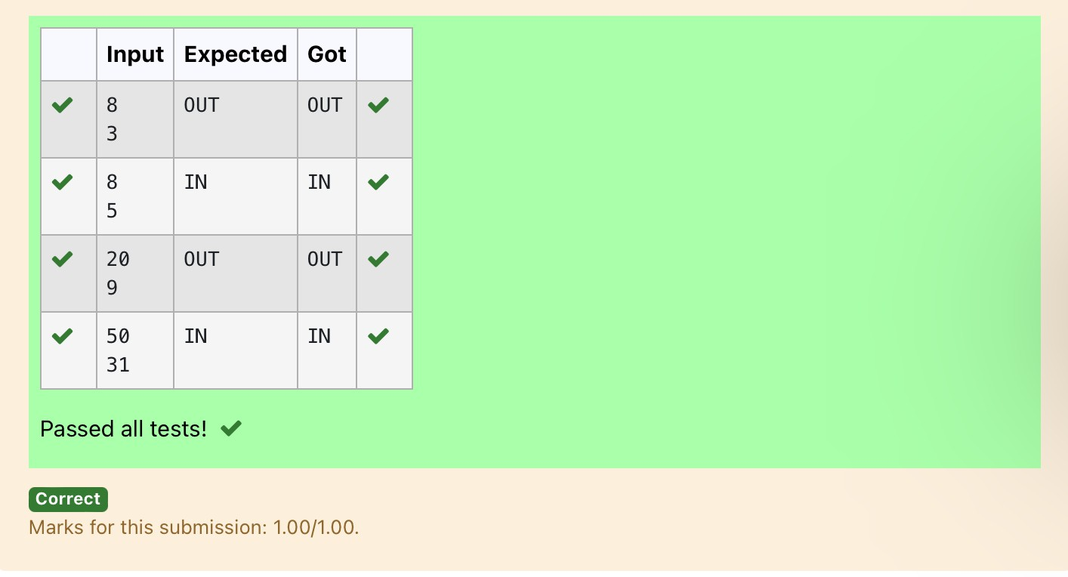

**Ex. No. : 3.5 Date: 10/4/24**

**Register No.: 231801073 Name: Joseph Obearai J**

## [VowelorConsonant](https://www.rajalakshmicolleges.net/moodle/mod/quiz/view.php?id=5710)

In this exercise you will create a program that reads a letter of the alphabet fromtheuser. If the user enters a, e, i, o or uthen your programshould display a messageindicating that the entered letter is a vowel. If the user enters 'y' then your program should display a message indicating that sometimes y is a vowel, and sometimes y isa consonant. Otherwise your program should display a message indicating that the letter is a consonant.

SampleInput1 i

SampleOutput1 It's a vowel.

SampleInput2 y

SampleOutput2

Sometimesit'savowel...Sometimesit'saconsonant.

SampleInput3 c

SampleOutput3 It's a consonant.

**For example:**

|  |  |
| --- | --- |
| **Input** | **Result** |
| y | Sometimesit'savowel...Sometimesit'saconsonant. |
| u | It'savowel. |
| p | It'saconsonant. |

# Program:

a=input()

if(a=='a'ora=='e'ora=='i'ora=='o'ora=='u'): print("It's a vowel.")

elif(a=='y'):

print("Sometimesit'savowel...Sometimesit'sa consonant.")

else:

print("It'saconsonant.")

# Output:

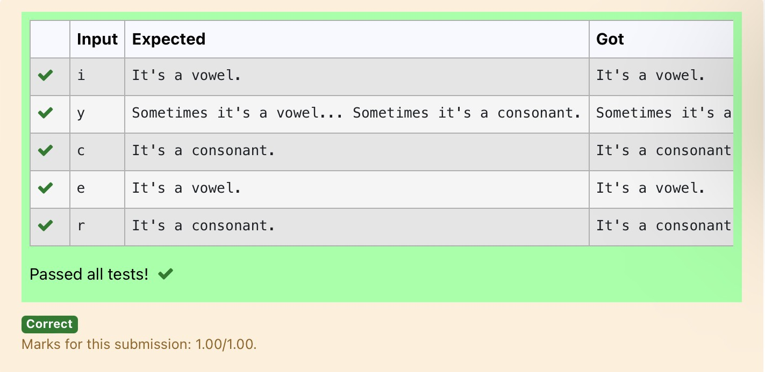

**Ex. No. : 3.6 Date: 10/4/24**

**Register No.: 231801073 Name: Joseph Obearai J**

## [Leap Year](https://www.rajalakshmicolleges.net/moodle/mod/quiz/view.php?id=5711)

Mostyearshave365days.However,thetimerequiredfortheEarthtoorbittheSun is actuallyslightlymorethanthat.Asaresult,an [extra](https://www.rajalakshmicolleges.net/moodle/mod/quiz/view.php?id=5753) day,February29,isincluded in someyearstocorrectforthisdifference.Such yearsarereferredtoasleapyears. The rules for determining whether or not a year is a leap year follow:

* Anyyearthatisdivisibleby400isaleap year.
* Oftheremainingyears,anyyearthatisdivisibleby100isnotaleapyear.
* Oftheremainingyears,anyyearthatisdivisibleby4isaleapyear.
* Allotheryearsarenotleapyears.

Writeaprogramthatreadsayearfromtheuseranddisplaysamessageindicating whether or not it is a leap year.

SampleInput1

1900

SampleOutput1

1900isnotaleap year.

SampleInput2

2000

Sample Output 2 2000isaleapyear.

# Program:

year=int(input()) if(year%400==0):

print(year,"isaleapyear.") else:

print(year,"isnotaleapyear.")

# Output:

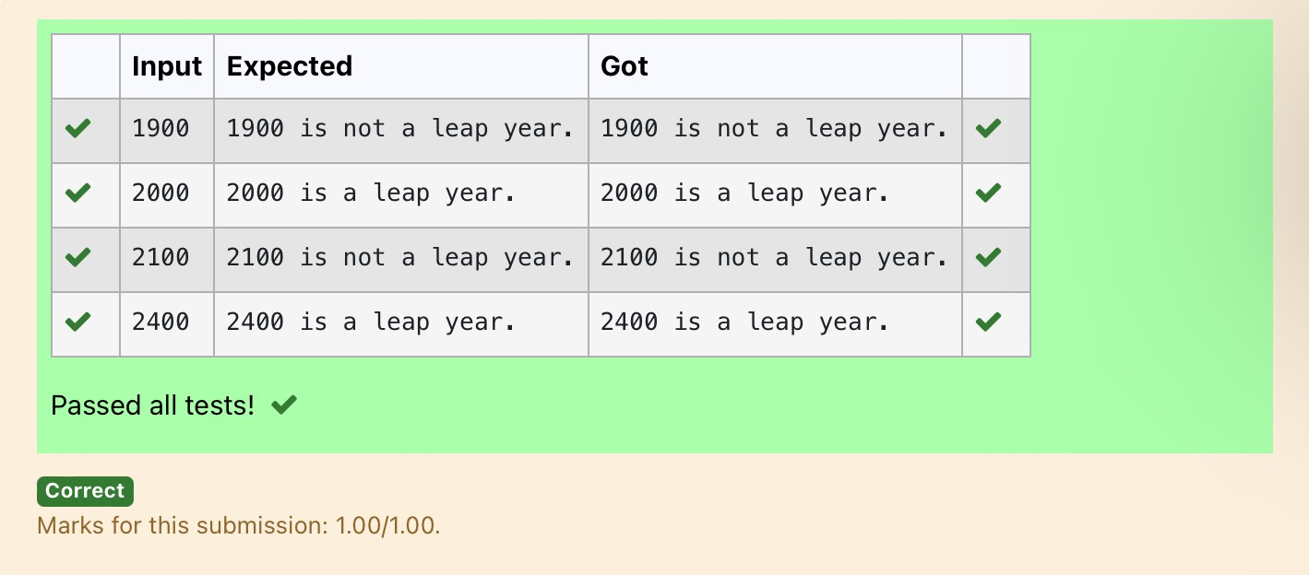

**Ex. No. : 3.7 Date: 10/4/24**

**Register No.: 231801073 Name: Joseph Obearai J**

## [Monthnametodays](https://www.rajalakshmicolleges.net/moodle/mod/quiz/view.php?id=5712)

The length of a month varies from 28 to 31 days. In this exercise you will create a programthatreadsthenameofamonthfromtheuserasastring.Thenyourprogram shoulddisplaythenumberofdaysinthatmonth.Display“28or29days”forFebruary so that leap years are addressed.

Sample Input 1 FebruarySampleOutput1

Februaryhas28or29daysinit. Sample Input 2

March

Sample Output 2Marchhas31daysinit. Sample Input 3

April

Sample Output 3Aprilhas30daysinit. **For example:**

|  |  |
| --- | --- |
| **Input** | **Result** |
| February | Februaryhas28or 29daysin it. |
| March | Marchhas31daysinit. |

# Program:

m=input() if(m=="January"):

print(m,"has31daysinit.") elif(m=="February"):

print(m,"has28or29daysinit.") elif(m=="March"):

print(m,"has31daysinit.") elif(m=="April"):

print(m,"has30daysinit.") elif(m=="May"):

print(m,"has31daysinit.") elif(m=="June"):

print(m,"has30daysinit.") elif(m=="July"):

print(m,"has31daysinit.") elif(m=="August"):

print(m,"has31daysinit.") elif(m=="September"):

print(m,"has30daysinit.") elif(m=="October"):

print(m,"has31daysinit.")

elif(m=="November"): print(m,"has30daysinit.")

elif(m=="December"): print(m,"has31daysinit.")

# Output:

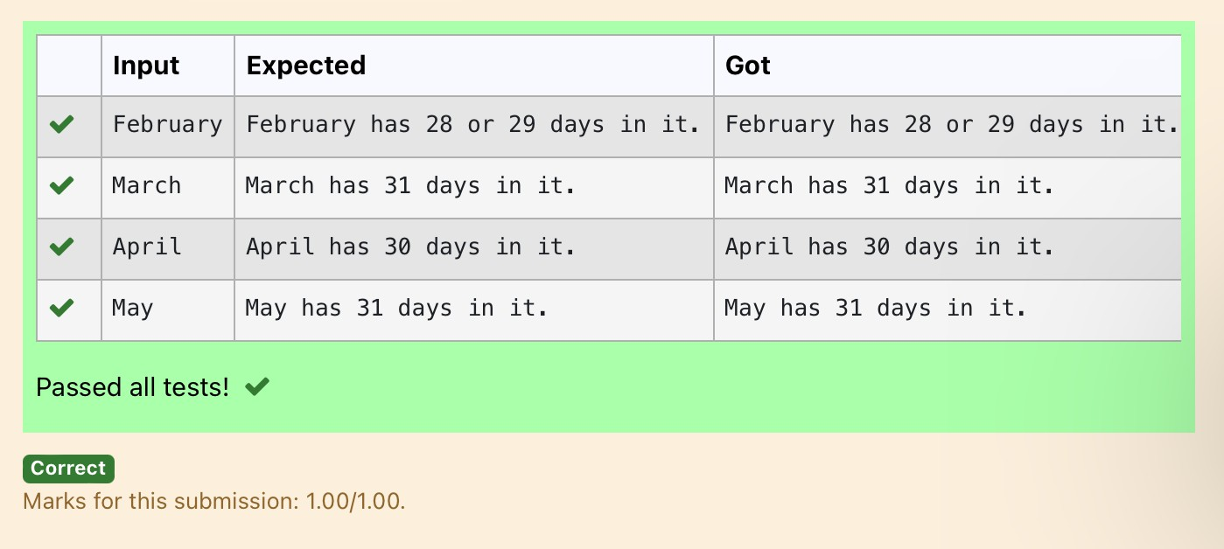

**Ex. No. : 3.8 Date: 10/4/24**

**Register No.: 231801073 Name: Joseph Obearai J**

## [Pythagoreantriple](https://www.rajalakshmicolleges.net/moodle/mod/quiz/view.php?id=5713)

Three numbers form a Pythagorean triple if the [sum of squares](https://www.rajalakshmicolleges.net/moodle/mod/quiz/view.php?id=5759)of two numbers is equal to the square of the third.

Forexample,3,5and4formaPythagoreantriple,since3*3+4*4=25=5*5 You are given three integers, a, b, and c. They need not be given in increasing order. If they form a Pythagorean triple, then print "Yes", otherwise, print "No".

**SampleInput**

3

5

4

**SampleOutput**

Yes

**Forexample:**

|  |  |
| --- | --- |
| **Input** | **Result** |
| 3  4  5 | Yes |

# Program:

a=int(input()) b=int(input()) c=int(input()) if(a*a+b*b==c*c):

print("yes")

elif(a*a+c*c==b*b): print("yes")

elif(c*c+b*b==a*a): print("yes")

else:

print("no")

# Output:

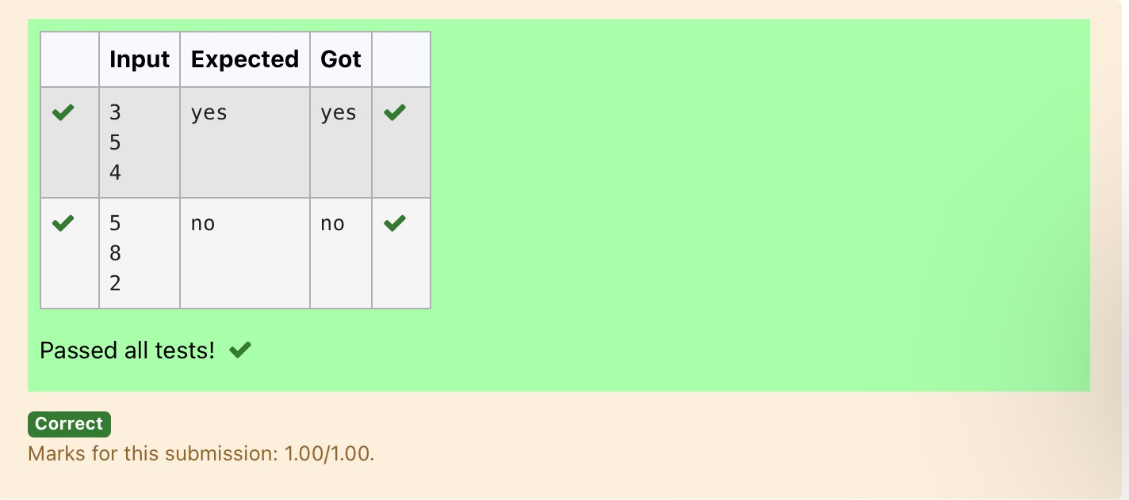

**Ex. No. : 3.9 Date: 17/4/24**

**Register No.: 231801073 Name: Joseph Obearai J**

## [Secondlastdigit](https://www.rajalakshmicolleges.net/moodle/mod/quiz/view.php?id=5714)

Write a program that returns the second last digit of the given number. Second last digit is being referred 10the digit in the tens place in the given number.

Forexample,ifthegivennumberis197,thesecond lastdigitis9.

Note1-Thesecondlastdigitshouldbereturnedasapositivenumber.i.e.ifthegiven number is -197, the second last digit is 9.

Note2 - If the given number is a single digit number, then the second last digit does not exist. In such cases, the program should return -1. i.e. if the given number is 5, the second last digit should be returned as -1.

**For example:**

|  |  |
| --- | --- |
| **Input** | **Result** |
| 197 | 9 |

# Program:

a=int(input()) b=str(abs(a)) l=len(b) if(l>1):

print(int(b[-2])) else:

print(-1)

# Output:

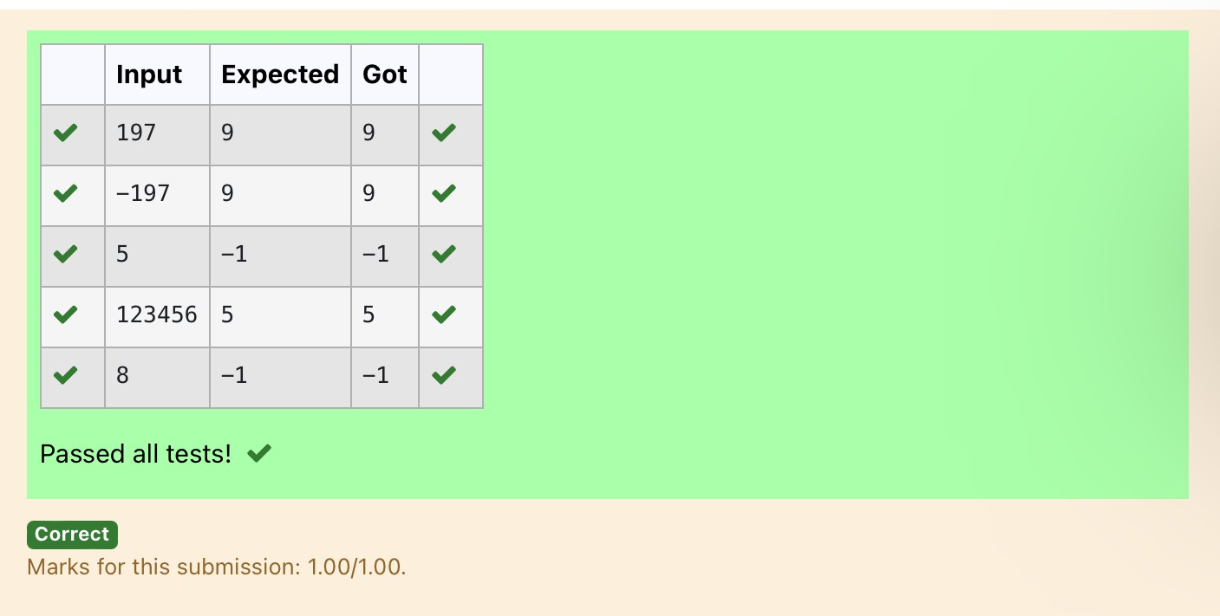

**Ex. No. : 3.10 Date: 17/4/24**

**Register No.: 231801073 Name: Joseph Obearai J**

## ChineseZodiac

TheChinesezodiacassignsanimalstoyearsina12yearcycle.One12yearcycle isshown in thetable below. Thepattern repeats from there, with 2012 being another year of the dragon, and 1999 being another year of the hare.

YearAnimal 2000Dragon

2001 Snake

2002Horse

2003 Sheep

2004 Monkey

2005Rooster

2006 Dog

2007 Pig

2008Rat

2009 Ox

2010 Tiger

2011 Hare

Writeaprogramthatreadsayearfromtheuseranddisplaystheanimal associated with that year. Your program should work correctly for any year greater than or equal to zero, not just the ones listed in the table.

SampleInput1

2010

SampleOutput1

2010istheyearoftheTiger. Sample Input 2

2020

SampleOutput2

2020istheyearoftheRat.

# Program:

a=int(input()) b=a%100

c=b%12 if(c==0):

print(a,"istheyearoftheDragon.") elif(c==1):

print(a,"istheyearoftheSnake.") elif(c==2):

print(a,"istheyearoftheHorse.") elif(c==3):

print(a,"istheyearoftheSheep.") elif(c==4):

print(a,"istheyearoftheMonkey.") elif(c==5):

print(a,"istheyearoftheRooster.") elif(c==6):

print(a,"istheyearoftheDog.") elif(c==7):

print(a,"istheyearofthePig.") elif(c==8):

print(a,"istheyearoftheRat.") elif(c==9):

print(a,"istheyearoftheOx.") elif(c==10):

print(a,"istheyearoftheTiger.")

elif(c==11):

print(a,"istheyearoftheHare.")

Output:

